**Vascular Imaging Core Facility**

**Manual of Procedures**

**University of Maryland School of Medicine**

Sponsored by

National Institute of Neurological Disorders and Stroke (NINDS)

National Institutes of Health (NIH)

**CREST-2**

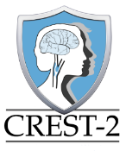

**CREST-H**

***v 2.1***



Brajesh K Lal, MD

Professor of Vascular Surgery

Director

John Huston III, MD

Professor of Radiology, Mayo Clinic

Rishi Kundi, MD

Assistant Professor of Vascular Surgery

John Yokemick RDMS, RT (R), RVT

Lead Research Ultrasound Reader/Reviewer

Kylie Milstead AA, RVT

Ultrasound Reader/Reviewer

Lauren Luther BS

Data Control Specialist

Matthew Chrencik, BA

Data Control Specialist

Kurt Gruber, MS

Information Technology Manager

Jonathan Sauder, MS

Information Technology

# Contact Information

|  |  |  |
| --- | --- | --- |
| **Vascular Imaging Core/Ultrasound protocols/CT Angiograms/Image transfer protocols** | | |
| John Yokemick RDMS RT (R) RVT, VIC Project Manager | (410) 328-0975 | [jyokemick@som.umaryland.edu](mailto:jyokemick@som.umaryland.edu) |
| Brajesh K Lal MD | (410) 328-5840 | [blal@som.umaryland.edu](mailto:blal@som.umaryland.edu) |
|  | | |
| **Plaque and Brain structural MR Imaging protocols** | | |
| John Huston III MD | (507) 255-1222 | [jhuston@mayo.edu](mailto:jhuston@mayo.edu) |
|  | | |
| **Perfusion weighted MR imaging protocol** | | |
| David Liebeskind MD | (310) 825-0703 | [davidliebeskind@yahoo.com](mailto:davidliebeskind@yahoo.com) |
|  | | |
| **CREST-2 study recruitment/retention/implementation** | | |
| Eldina Cesko, CREST-2 Project Manager | (904) 953 3305 | [Cesko.Eldina@mayo.edu](mailto:Cesko.Eldina@mayo.edu) |
| Thomas G Brott MD | (904) 953 8133 | [Brott.Thomas@mayo.edu](mailto:Brott.Thomas@mayo.edu) |
| James F Meschia MD | (904) 953 8241 | [Meschia.James@mayo.edu](mailto:Meschia.James@mayo.edu) |
|  | | |
| **CREST-H study recruitment/retention/implementation** | | |
| Kevin Slane, CREST-H Project manager | (212) 342-1152 | [kjs4@columbia.edu](mailto:kjs4@columbia.edu) |
| Randolph Marshall MD | (212) 305-8389 | [rsm2@columbia.edu](mailto:rsm2@columbia.edu) |
| Ronald Lazar MD | (205) 934-2334 | [rlazar@uabmc.edu](mailto:rlazar@uabmc.edu) |

# Table of Contents

Contact Information 2

Table of Contents 3

1. SUMMARY OF KEY CHANGES TO THE MANUAL 7

2. PURPOSE 8

A. CREST-2 8

B. CREST-H 8

C. The Vascular Imaging Core Facility (VIC) 8

D. Summary of imaging studies 9

3. CAROTID DUPLEX ULTRASOUND SCANNING (CDUS) IN CREST-2 10

A. Carotid Case Report Form Components 10

B. Guidelines for completing the Case Report Form 17 10

C. Carotid Duplex Examination Testing Guidelines 15

D. Labeling and Saving Images and Waveforms 17

E. Plaque quantification images 18

F. Requirements for Carotid Endarterectomy: 20

G. Requirements for Carotid Stents 21

H. Documentation Requirements 22

I. Ultrasound Laboratory CREST Certification 22

J. VIC Ultrasound Review and Feedback 23

4. ADDITIONAL CAROTID IMAGING TO CONFIRM DEGREE OF STENOSIS IN CREST-2 25

A. Protocols for additional carotid imaging 25

B. Reimbursement for additional carotid imaging to determine stenosis 25

5. PRE-REVIEW OF IMAGING STUDIES FROM CLINICAL SITES FOR AN OPINION PRIOR TO ENROLLMENT 26

A. Protocols 26

B. Reimbursement 26

6. QUALITY CONTROL OF CAS PROCEDURES 27

A. Protocols 27

B. Reimbursement 27

7. BRAIN IMAGING TO EVALUATE A SUSPECTED NEUROLOGICAL EVENT IN CREST-2 28

A. Protocols for brain imaging to evaluate a neurological event 28

B. Reimbursement for brain imaging to evaluate a neurological event 28

8. BASELINE CAROTID PLAQUE IMAGING IN CREST-2 29

A. Protocols for carotid plaque imaging 29

B. Reimbursement for carotid plaque imaging 34

C. Form to be filled electronically for carotid plaque imaging 34

9. END OF STUDY BRAIN MRI IN CREST-2 35

A. Protocols for end of study brain MRI 35

B. Reimbursement for end of study brain MRI 40

C. Form to be filled electronically for end of study brain imaging 40

10. BRAIN IMAGING FOR CREST-H 41

A. Protocols for CREST-H and carotid plaque imaging 41

B. Reimbursement for CREST-H MR imaging 51

11. NAMING OF IMAGE FILES BEFORE TRANSFER TO THE VIC 52

12. SUBMISSION OF IMAGES TO THE VIC 54

13. OPTIONS AND REIMBURSEMENT FOR IMAGING STUDIES IN CREST-2 AND CREST-H 55

# SUMMARY OF KEY CHANGES TO THE MANUAL

1. All pages: Change in version number to Version 2.0
2. Page 4: Added summary of key changes to the manual
3. Pages 5-6: Added a description and table of imaging studies being collected in the trial
4. Page 8: Added item 8d to reflect **new requirement** to obtain a 15-second video loop of the longitudinal image of the plaque using B-mode ultrasound
5. Page 16: Added item B.5, instructions on how to obtain the 15-second video loop of the plaque in B-mode.
6. Page 22: Added new chapter on additional carotid imaging to confirm degree of stenosis
7. Page 23: Added new chapter on pre-review of imaging studies from clinical sites for an opinion prior to enrollment
8. Page 24: Added new chapter on quality control of CAS procedures
9. Page 25: Added new chapter on brain imaging to evaluate a suspected neurological event in CREST-2
10. Page 26: Added new chapter on **new requirement** for baseline carotid plaque imaging in CREST-2
11. Page 30: Added new chapter on **new requirement** for end of study brain MRI in CREST-2
12. Page 34: Added new chapter on brain imaging for CREST-H
13. Page 41: Added new chapter describing naming of imaging files before transfer to the VIC
14. Page 43: Added new chapter on submission of images to the VIC
15. Page 44: Added new chapter describing how to determine which images are required for your patient, and which ones are eligible for reimbursement from the trial

# PURPOSE

## CREST-2

**CREST-2** (clinicaltrials.gov NCT02089217) is a pair of clinical trials for patients with asymptomatic high-grade carotid artery stenosis, which compares stroke prevention and death for carotid endarterectomy (CEA) plus intensive medical management (IMM) versus IMM alone, and carotid artery stenting (CAS) plus IMM versus IMM alone. An important eligibility criterion for CREST-2 is that patients must have **imaging studies confirming a carotid stenosis ≥70%** based on a protocol carotid duplex ultrasound scan (CDUS) or a catheter based angiogram (CBA). In the event of a **suspected neurological end-point**, sites must submit any brain or neck imaging performed for the workup of the patient. The trial organizers welcome the opportunity to **pre-review any imaging studies** that sites may wish to submit that may help them in deciding whether to consider enrollment of a patient. As a quality measure, once sites have randomized their first 3 patients to undergo stenting, they must submit these **3 CAS procedural angiograms** for review. An amendment was approved for the CREST-2 study in February, 2018 to add 2 imaging studies: a protocol **baseline plaque imaging study** to be done at the time of enrollment, and a protocol **end-of-study brain imaging** to look for presence of silent brain lesions.

## CREST-H

**CREST-H** (clinicaltrials.gov: NCT03121209) is a companion study to CREST-2. It is designed to determine whether a subset of CREST-2 patients who have cerebral hemodynamic impairment and mild cognitive impairment will have better cognitive outcomes if they receive CEA or CAS than if they receive IMM alone. Patients enrolled in CREST-H will get a protocol **brain perfusion weighted imaging MRI (PWI) at baseline**. Those who have hemodynamic impairment at baseline will receive a protocol **brain perfusion weighted imaging MRI (PWI) at 1 year follow up**. This protocol imaging sequence includes brain imaging to look for presence of silent brain lesions.

## The Vascular Imaging Core Facility (VIC)

The VIC is located at the University of Maryland, Baltimore. The purpose of the VIC is to assure uniform examination and interpretation of imaging methods across all Clinical Sites participating in CREST-2 and CREST-H. This manual is to be used for all trial-related imaging studies. Studies covered include carotid duplex ultrasound (CDUS), carotid magnetic resonance angiography (MRA), brain MRI, brain perfusion-weighted imaging (PWI) MRI, carotid computed tomography angiography (CTA), and catheter based angiography. **Some studies need to be performed using a standardized protocol (protocol imaging) and are provided in this manual.** The manual provides a description for each type of imaging sequence, including specific details when a mandatory protocol is required. Where appropriate, imaging protocols specific to different imaging machines (e.g. GE, Phillips, Siemens) are provided. Protocols for additional machines will be added as necessary. The manual also contains a description of specific case report forms that must be completed to accompany the imaging studies that you are submitting. **Other studies can be performed using the standard methodology being used at Clinical Sites (clinical imaging).** These imaging studies are based on usual clinical ultrasound, MRI and CT sequences that are available at all clinical sites that perform carotid revascularization procedures. Therefore, Clinical Sites should be easily able to implement them. The manual also contains the method to name imaging files and to submit/upload imaging studies to the Vascular Imaging Core facility (VIC) at University of Maryland.

## Summary of imaging studies

|  |  |  |  |  |
| --- | --- | --- | --- | --- |
| **Purpose** | **Target** | **Name of study** | **Type of study** | **Timing** |
| CREST-2 |  |  |  |  |
| To determine eligibility for enrollment and annual follow-up | Carotid artery | CDUS | Protocol | Baseline and every year |
| To determine individual components of the carotid plaque | Carotid plaque | MRI/MRA | Protocol | Baseline |
| To look for presence of silent brain lesions | Brain parenchyma | MRI | Protocol | At exit from study |
| If additional imaging was used to determine eligibility or to determine appropriate trial (CEA or CAS); submit one or more | Carotid artery | * CTA * MRA * CBA | Clinical | Baseline |
| Pre-review of imaging studies that Clinical Sites may send for an opinion prior to enrollment; submit one or more | Carotid artery | * CDUS * CTA * MRA * CBA | Clinical | Baseline |
| Quality control of CAS procedures | Carotid artery | Procedural CBA | Clinical | Procedural |
| To evaluate a potential neurological event; submit one or more | Brain parenchyma | * MRI/MRA * CT/CTA | Clinical | Any time during the study |
| CREST-H |  |  |  |  |
| To measure brain perfusion and look for silent brain injury | Brain | * Perfusion-weighted imaging (PWI) MRI * Brain MRI | Protocol | Baseline and at 1 year follow-up |

# CAROTID DUPLEX ULTRASOUND SCANNING (CDUS) IN CREST-2

This section is to be read by all ultrasound personnel who will be performing CDUS in the trial so that each site performs similar studies and documents findings in a similar fashion. We understand that there are site-to-site variations in how to perform and interpret CDUS tests. This protocol may also be slightly different than the one typically used for clinical patients. However, it is critical to the success of a clinical trial that *everyone* follow the same technique. Furthermore, the protocol is similar to that required by the Intersocietial Accreditation Commission (IAC) with additional information specifically collected relative to the grayscale image of the plaque, and to the stent if placed in the patient. Ultrasound staff is therefore required to commit to performing carotid duplex scans for trial patients as described in this protocol.

## Carotid Case Report Form Components

Before performing a CREST-2 carotid duplex ultrasound scan, please review the following directions on how to complete the ultrasound case report form (CRF). An original copy of the worksheet is appended at the back of the manual; this is your original Case Report Form 17. You may use copies of this blank form to ensure accurate completion of all required data. While you can use this paper form as a worksheet, you will ultimately have to enter the CRF data electronically to submit it through the electronic data submission software. In addition, the accompanying images can be submitted through a web-based file transfer system (preferred) or saved on a CD/DVD and mailed to the VIC.

## Guidelines for completing the Case Report Form 17

**HEADER- PID: Patient ID,** These identifiers should be supplied by your site research coordinator.

**1. Date of Study:** Date that study was done

**2. Ultrasonographer performing exam:** is the pre-certified RVT/RVS who is completing the examination. Each sonographer has a unique identifying code; please enter that here

**3. Name of Machine**: Please list name of manufacturer (and model) of the machine used in the exam.

**3.A. Transducer type (e.g. L9-3)**: Please document frequency of probe (and linear or curved) used in exam.

**4. Index (randomized) Artery** is the artery that has been randomized in the trial and that is the focus of the study.

**5. VISIT:** Check the appropriate box to indicate which exam is being performed: baseline evaluation at the time of enrollment; 1, 2, 3 or 4 year follow-up; Non-Protocol. Non-Protocol will apply to any scan performed that does not fall into one of the provided choices. Please give a description of why this patient underwent the additional scan. For instance, this may be due to a stroke or re-intervention, or you may check “other” and write “routine clinical’” if it is the clinician’s practice to perform this additional scan outside of the CREST-2 protocol schedule.

**6. Recording/confirming that all required velocities and waveforms have been evaluated, obtained, and recorded:** Enter values for each specific measurement. Using the Core Lab Carotid Diagnostic Criteria, please enter the category of stenosis in each carotid artery (right and left).

**6A. If a velocity, waveform or image was not evaluated you must indicate a reason why it was not obtained:** Please document thoroughly the reason any image or velocity was not obtained.

**6B. Angle of insonation confirmation:** Select Yes or No to confirm that velocities were obtained at the recommended angle of insonation. If no, you must indicate a reason why it was not so obtained.

**7, 7a1, 7a2: Stent Information:** If a stent was utilized in the patient, please indicate the location of the stent within the carotid artery (from specific arterial segment 🡪 to specific arterial segment).

**7b. Were Doppler waveforms for proximal, middle, and distal stents documented?** Check yes if done and no if not. Please document reason if answer is no.

**8. Plaque Image. Please confirm that longitudinal views of the plaque were recorded** as follows:

**8a. B-mode image of the plaque:** Confirm that the longitudinal image was obtained and if not, explain why.

**8b. Color flow image of the plaque.** Confirm that the longitudinal color flow image was obtained and if not, explain why.

**8c. Power Doppler image of the plaque.** Confirm that the longitudinal color power (or equivalent) image was obtained, and if not, explain why.

8d. **Video loop of B-mode image of the plaque (15 seconds).** Confirm that the video loop was obtained and if not, explain why.

**9. Additional Comments.** Please remark on any patient issues that may have influenced the outcome of the study.

**10. Confirm the method you used to transmit images to the Core Facility. Note that ftp is strongly recommended.**

|  |  |
| --- | --- |
| **CREST-2** Page 1 of 4 | |
| **PID1: ___ ___ ___ - ___ ___ ___ ___**  **SITE ID** | **PID2: ___ ___ ___ - ___ ___ ___ ___ ___**  **SITE ID** |
| **FORM 17**  **SITE DUPLEX ULTRASOUND FORM** | |
| ***Instructions:***  **This form is to be completed by the clinical center vascular lab. The associated images of the duplex ultrasound study must be transferred electronically to the Vascular Imaging Core lab at the University of Maryland using their File Transfer Protocol (FTP) site or must be saved on a CD/DVD and mailed to them.** | |
| 1. Date of study: __ __ /__ __ /__ __ __ __   MM DD YYYY | |
| 1. Ultrasonographer Performing Exam (code) ______________________________________________ | |
| 1. Name of machine: ________________________________________________   3.A. Transducer type (e.g. L9-3): ________________MHz | |
| 1. Target (randomized) Artery:  1=Right  2=Left | |
| 1. Visit:   Baseline  1 Year Follow-up  2 Year Follow-up  3 Year Follow-up  4 Year Follow-up  Non-protocol  Post Stroke  Post Re-intervention  Other, please specify:______________________ | |
| **CREST-2** Page 2 of 4 | |
| **PID1: ___ ___ ___ - ___ ___ ___ ___**  **SITE ID** | **PID2: ___ ___ ___ - ___ ___ ___ ___ ___**  **SITE ID** |
| **FORM 17**  **SITE DUPLEX ULTRASOUND FORM** | |
| 1. For each location, mark whether Doppler waveforms were evaluated and recorded. Please fill in the highest result for each of the following measures for both the right and left internal carotid artery (ICA) and common carotid artery (CCA) for each location.  | **RIGHT** | | | **VELOCITY LOCATIONS** | **LEFT** | | | | --- | --- | --- | --- | --- | --- | --- | | Doppler waveform evaluated and recorded | Peak Systolic Velocity (cm/s) | End Diastolic Velocity (cm/s) | Doppler waveform evaluated and recorded | Peak Systolic Velocity (cm/s) | End Diastolic Velocity (cm/s) | |  | __ __ __ | __ __ __ | Distal ICA |  | __ __ __ | __ __ __ | |  | __ __ __ | __ __ __ | Middle ICA |  | __ __ __ | __ __ __ | |  | __ __ __ | __ __ __ | Proximal ICA |  | __ __ __ | __ __ __ | |  | __ __ __ | __ __ __ | Distal CCA |  | __ __ __ | __ __ __ | |  | __ __ __ | __ __ __ | Middle CCA |  | __ __ __ | __ __ __ | |  | __ __ __ | __ __ __ | Proximal CCA |  | __ __ __ | __ __ __ | | ICA/CCA Ratio __ __ __ | | |  | ICA/CCA Ratio __ __ __ | | | | Stenosis category __ __- __ __ % | | |  | Stenosis category __ __- __ __ % | | |   6.A. If Doppler waveforms were NOT evaluated and recorded, please indicate at which location AND reason: _______________________________________________________________________________________________________________________________________________________________________________________________________________________________________________________________  _____________________________________________________________________________________  6. B. Are angles 60° or 0°?  1=Yes  2=No, reason ______________________________________ | |
| **CREST-2** Page 3 of 4 | |
| **PID1: ___ ___ ___ - ___ ___ ___ ___**  **SITE ID** | **PID2: ___ ___ ___ - ___ ___ ___ ___ ___**  **SITE ID** |
| **FORM 17**  **SITE DUPLEX ULTRASOUND FORM** | |
| If this is a baseline visit, please skip to question 8 OR  If patient did not receive a stent, please skip to question 8.   1. Did patient receive a stent?  1=Yes  2=No     If yes, please provide location (from 🡪 to) of stent:  7a1. From:  Distal CCA  Proximal ICA  7a2. To:  Proximal ICA  Mid ICA  Distal ICA  7b. Were Doppler waveforms for proximal, middle, and distal stent documented?  1=Yes  2=No, reason ____________________________ | |
| 1. Was a longitudinal view of the plaque recorded in:   8a. B-mode  1=Yes  2=No, reason ___________________________  8b. Color Flow Mode  1=Yes  2=No, reason ___________________________  8c. Power Doppler (or equivalent) mode  1=Yes  2=No, reason ___________________________  8d. 15-second video loop in B-mode  1=Yes  2=No, reason ___________________________ | |
| 1. Additional Comments ____________________________________________________________________   _____________________________________________________________________________________  _____________________________________________________________________________________  _____________________________________________________________________________________ | |
| **CREST-2** Page 4 of 4 | |
| **PID1: ___ ___ ___ - ___ ___ ___ ___**  **SITE ID** | **PID2: ___ ___ ___ - ___ ___ ___ ___ ___**  **SITE ID** |
| **FORM 17**  **SITE DUPLEX ULTRASOUND FORM** | |
| 1. Please select method of image transfer to University of Maryland:   1= File transfer protocol site  10.A. Date of transfer: __ __ /__ __ /__ __ __ __  MM DD YYYY  2= Courier  10.B. Specify courier: ________________________________________  10.C. Date of shipment __ __ /__ __ /__ __ __  MM DD YYYY  10.D. Tracking number: _____________________ | |

## Carotid Duplex Examination Testing Guidelines

**1. Basic considerations**: Scan-head orientation: All ultrasound grayscale images, including those associated with Doppler waveforms, should be taken with the scan-head “notch” oriented cephalad and the image “icon” on the left of the image so that image is correctly oriented in the longitudinal plane. The Doppler cursor line should be directed so that “Forward” flow (upward deflection) represents flow in the cephalad direction.

Grayscale images used for Doppler angle measurement MUST be provided for each location sampled, and saved with the color flow/color power angiography turned off. Color obstructs visualization of the angle cursor and impairs the ability to review them.

**2. Minimum required velocities:** Six waveforms on each side form the minimum samples required, and come from the carotid pathway to the brain. Each sample represents a 2 cm segment (except the proximal ICA) along the path of the artery centered around the flow divider of the carotid bifurcation. Once appropriately located, save the image showing the sample gate and associated waveform. Annotate the peak systolic and end diastolic velocities on the waveforms. Annotate the location of sample within the carotid arterial tree and then save the image.

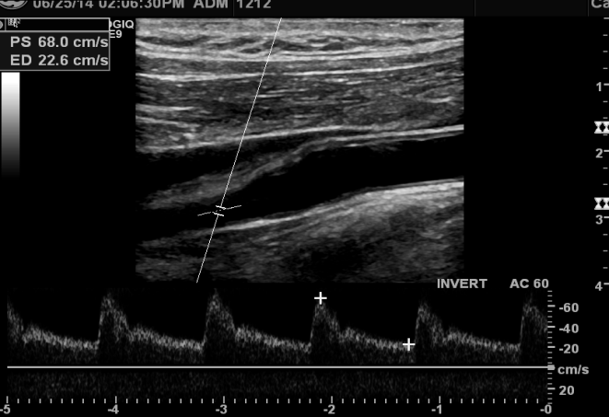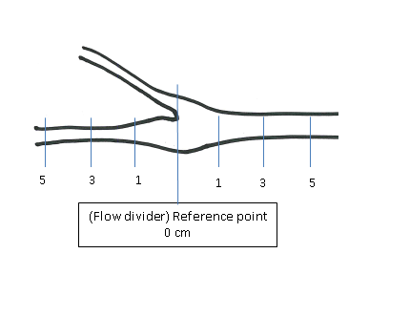

**3. Post stenotic turbulence.** Each waveform must be taken from the location of maximum velocity increase in that segment. Each signal taken within a stenosis must have an accompanying post stenotic waveform for validation of true stenosis. PST is defined as the presence of negative velocities on the spectral waveform at the time of the highest peak systolic velocity in the waveform.

The image shows a representative spectral waveform documenting post stenotic turbulence (PST) which follows a hemodynamically significant stenosis. The flow pattern represents random, somewhat chaotic flow activity and a collective decrease in the overall velocity distal to the stenotic jet. The waveform may be bidirectional in character, damped in shape and will most likely have a jagged or “spiked” outer envelope, representing the rapid flow directional changes of eddy currents.

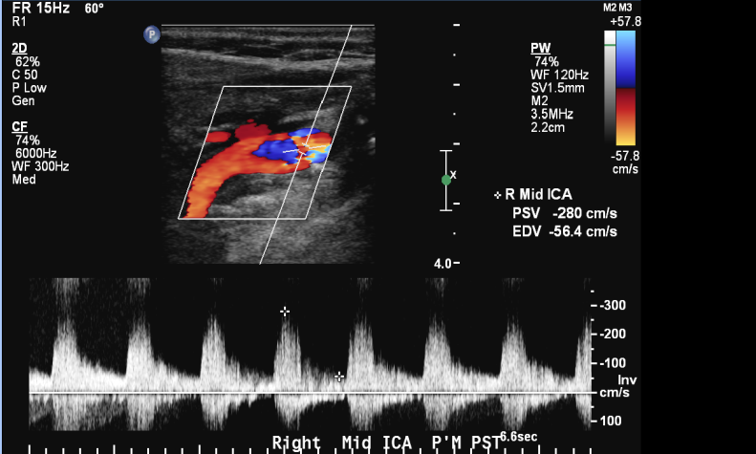

The extent to which this waveform varies from the stenotic jet will be related to the amount of diameter narrowing and the shape of the stenosis, as well as the distance downstream from which the signal was taken. The waveform may normalize if it is taken far enough distal to the stenosis. Therefore, the **post stenotic waveform should be sampled within 1 cm distal to the documented maximum velocity jet.**

It may be difficult, even meaningless, to accurately measure the peak systolic velocity of a post stenotic waveform due to its jagged appearance. It is less important to have an accurate measurement of this signal as compared to the stenotic signal. The purpose of the post stenotic signal is to demonstrate that the velocity jet has dissipated beyond the stenosis and that the overall velocity has decreased. The presence of this turbulent waveform following a suspected velocity increase is the best landmark of the distal extent of the lesion and **is essential in order to validate that a velocity increase has been caused by a stenosis.**

**4. More velocity samples may be required if a stent is in place.** **If a stent is in place, the Distal ICA waveform must come from a location at least 1 cm distal to the distal end of the stent in the native artery.** If the Distal ICA waveform is taken inside the stent, then an additional waveform should be taken at least 1 cm distal to the stent to document that there is no stenosis in the native artery distal to the stent. Images should be annotated with arrows marking the beginning and the end of the stent for reference in verifying velocity data.

**5. Aliasing:** Aliased waveforms should be avoided. When aliasing is present on the spectral waveform, first increase the PRF (velocity range) of the Doppler system, then lower the baseline. If aliasing/wraparound cannot be averted, attempt to locate the peak of systole (or end diastole) and set the cursor on that value. Note the following examples:

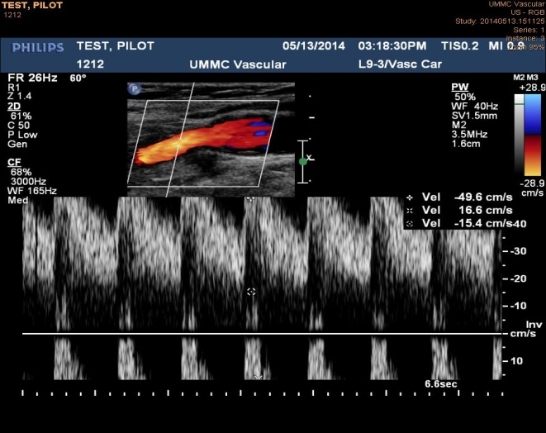

On the left, PSV = A+B-C, while on the right, PSV = A+B+C (A, B & C are positive)

**6. Exam Angle: Doppler** **angles of 60 or 0 degrees are the only acceptable angles permitted**. **An examination angle of greater than 60 degrees should never be used**. While a vessel may be difficult to study due to the angle of the vessel relative to the orientation of the scan-head, every attempt must be made to document the flow changes. Obtaining 60 degree angles is often possible by steering the Doppler beam. The stenosis classification method is based on velocities taken at 60 degrees with the cursor parallel to the vessel axis and cannot be used accurately with velocities taken at angles other than 60 degrees. If a zero degree angle is used, the cursor must still be parallel to the vessel walls.

**7. Unidentified, Absent or Occluded arteries.** If a vessel segment cannot be identified, a representative image of that region of interest should be saved, the corresponding field on the form should be marked “999”, and a reason should be stated in Q 6A of the CRF 17, as follows “Segment (name of segment) could not be identified”. If the vessel segment can be seen but no Doppler signal can be obtained, the image should be saved per protocol, the corresponding velocity field on the form should be filled in as “000”, and the space in Q 6A of CRF 17 should be used to state “Vessel segment (name of segment) was occluded”. For an ICA or a CCA occlusion, all appropriate locations must be shown to demonstrate no flow as verified by an absence of waveforms.

## Labeling and Saving Images and Waveforms

**1. Identifiers:** All images should identify the Site #, Patient #, and Ultrasound Date, as well as the side and site of the exam. The Site #, Patient # and Name Code should be written on the CD if that is how images will be submitted to the Core Lab; they should be stated in the file name, if file transfer protocol (ftp) will be used to send images.

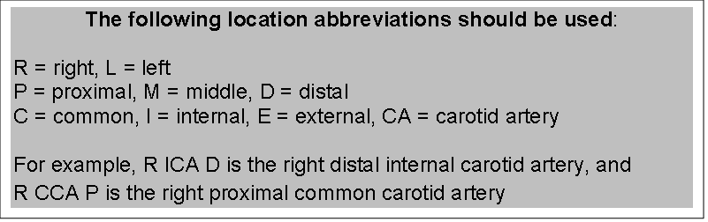

**2. Measuring systole and diastole:** Each waveform should include measuring calipers placed at the peak systolic velocity measurement point and the end-diastolic measurement point, just before the upstroke of Systole. The display should include a read-out of the Doppler examination angle and the velocity values corresponding to the cursors. The angle and the systolic and diastolic values must be visible on each image saved for each segment sampled. Please note that in patients with arrhythmias, you must make every effort to avoid taking measurements off the compensatory waveform.

**3. Image order:** Note that “Bulb” or “Bifurcation” is not a protocol location.

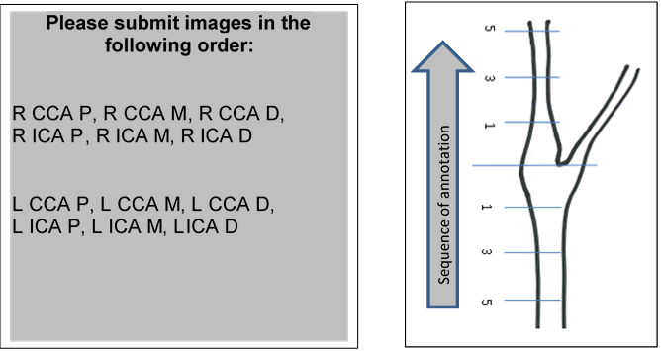

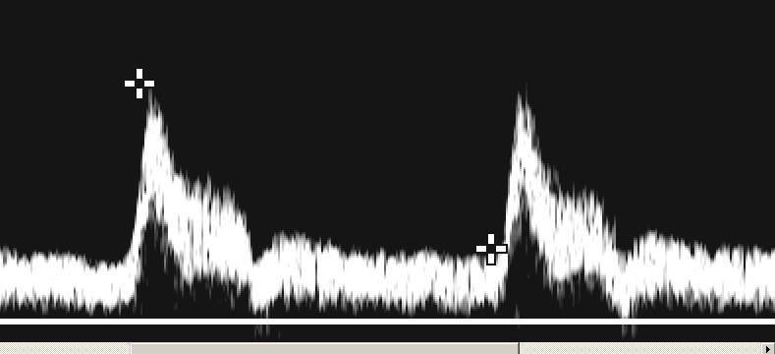**4. ICA/CCA Peak Systolic Ratio Calculation:** The ratio is computed for each side using the **Middle CCA** peak systolic measurement value from that side for the **denominator** if there is no disease present and the waveform is normal. If the MCCA waveform is not normal, then the Proximal CCA peak systolic measurement value from that side may be used for the denominator.

The **numerator** is selected from the greatest of the peak systolic values for the Distal CCA, Proximal ICA, or Middle ICA. Samples from areas containing post-stenotic turbulence should not be used to compute the ratio.

## Plaque quantification images

A grayscale image of the carotid plaque in the index (randomized) artery should be obtained in the longitudinal plane. If a carotid plaque is present in the contralateral artery, a representative 2D image should be taken as well.

**A. Machine Settings**

The CREST-2 plaque image is obtained using a protocol very similar to that used clinically to identify the location of the plaque in longitudinal view. We do require that your machine settings be adjusted in the following standard way to ensure optimized image-quality while reducing variability between different centers and patients. **The aim is to obtain maximum pixel data with least image modification by the scanner or operator.**

1. The dynamic-range should be set to maximum to ensure the greatest display of greyscale values and texture detail
2. Pre- and post-processing should be kept as minimal as possible.
3. Persistence should be set to “low”, and frame-rate set to “high” to increase temporal resolution
4. Depth gain compensation or the TGC knobs should be maintained as gently sloping but vertical through the lumen of the artery
5. The final adjustment should be made to overall gain. It should be changed to show the blood as dark as possible while keeping the peri-arterial adventitial tissue clearly visible. The goal is to obtain a vessel lumen that is relatively noiseless, with an echo-dense area of periarterial tissue in the vicinity of the plaque, and with an echoically informative plaque that can easily be outlined.

|  |  |  |  |  |  |  |
| --- | --- | --- | --- | --- | --- | --- |
|  | **GE** | **Philips** | **Mindray** | **Zonare** | **Seimens** | **Toshiba** |
| **Dynamic Range** | Dynamic Range | Dynamic Range or Compression on the q50 | Dynamic Range | Dynamic Range | Dynamic Range | Dynamic Range |
| **Pre Processing** | Rejection/Suppression | N/A | N/A | Not adjustable | No (turn off Sie Clear) | Pre Processing |
| **Post Processing** | Rejection/Suppression | N/A | N/A | edge or map | post processing (no tint) | Post Processing |
| **Persistence** | Frame Average | Persistence | Persistence | Persistence | Persistence | Persistence |
| **Frame Rate** | Not labeled, Just decrease focal zones | Res/SPD increase to SPD | Frame Rate | Frame Rate | Frame Rate (turn off space/time control on scanner) | Frame Rate |

**B. Imaging Procedure**

1. Once the above machine settings are achieved, the transducer is positioned at 90 degrees to the longitudinal axis of the artery and the plaque is visualized
2. The image is magnified to as large as possible while still including the entire plaque in the field
3. The best longitudinal image of the plaque is then obtained in grayscale then color-flow and then power-Doppler modes
4. The purpose of providing the color images is to assist in outlining the plaque in the grayscale image. If you feel that certain parts of the plaque edges are seen better in additional color-flow or power-Doppler images, please obtain and save those images too
5. Maintaining the probe orientation and settings used for the B-mode still imaging, ask the patient to hold their breath, and a continuous, **fifteen-second long, grayscale cine loop (video loop)** should be recorded. As in the still images, the entire plaque should be clearly visible throughout the recording, and the probe should not be moved.
6. **You cannot go wrong with MORE images!**

## Requirements for Carotid Endarterectomy:

**A. Sample Sites in patients that have undergone CEA** are no different from those you would do in an un-operated carotid artery.

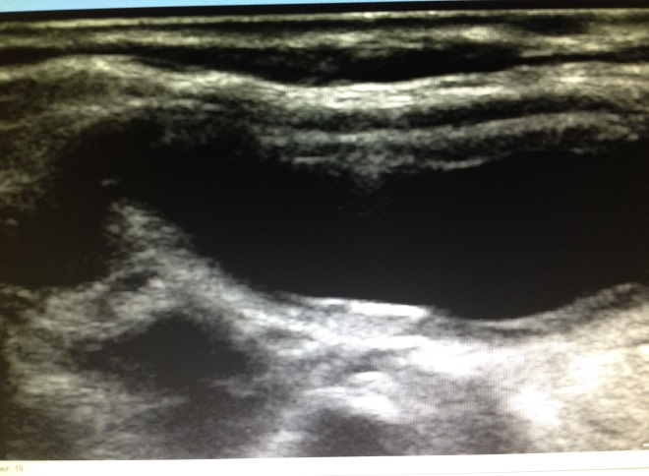**B. CEA with patch angioplasty.** The drawing represents a carotid bifurcation following a carotid endarterectomy (CEA) with a patch closure of the arteriotomy. The large dots seen within the vessel represent the sites where spectral waveforms should be sampled to document representative flow patterns after a thorough investigation of the length of the vessels. The dashed line represents the sutures along the patch. The sutures may be seen as bright, evenly spaced echoes along the near wall of the CCA and ICA in the B- mode image. The patch can create a dilatation at the endarterectomy site of varying dimensions.

While a vein patch will be indistinguishable in appearance from the wall of the native artery, the dilatation and the sutures can help to identify its presence. Prosthetic patches will have a typical ultrasound signature of the specific material that will easily distinguish them from the native vessel wall. For example, a Dacron patch will appear as a thick, brightly echogenic surface and PTFE (polytetrafluoroethylene) will typically appear as a bright “double line” which represents the thickness of the material and the effects of the ultrasound penetration.

There will be accompanying flow disturbances that occur as a result of the dilatation created by the patch closure of the endarterectomy. These flow disturbances are similar to those that occur in the normal carotid bulb. The amount of flow disturbance will be directly related to the size of the dilated patched vessel. Hence, more flow disturbances would be expected in a large dilatation as compared to a smaller one. Again, it is important to scan through the entire length of the patch and **to a location distal to the end of the patch**, documenting typical flow changes in, throughout and exiting the patch into the native ICA. These measurement locations may be in addition to the standard ICA and CCA locations.

**C. The Shelf.** Following an endarterectomy, there may be an obvious “shelf” or “lip” of wall thickening seen on the far wall and sometimes on the near wall of the distal CCA. This thickening is a result of the beginning of the plaque excision. The first sutures will also be found in this area. The thickness of a shelf will depend on the amount of wall thickening that was present prior to the CEA. There are usually minor flow disturbances associated with this area; more disturbances are seen with a more prominent shelf.

It is important to thoroughly investigate this area with the sample volume of the pulsed

Doppler and to document flow changes that are representative of the hemodynamics present. Thus, the CCA M signal may be taken just proximal to the shelf and the CCA D may be taken just distal to the shelf if there are no flow disturbances present.

A signal must also be taken just at the site of the shelf if there are flow changes that are significant. Recurrent stenosis, i.e. intimal hyperplasia, may develop at the shelf site as a result of the injury to the wall; making it important to demonstrate any flow changes in that location. Intimal flaps and other technical problems of surgery may also be found at this site.

A shelf may also be present in the DICA at the end of an endarterectomy. This distal location is a common site for intimal hyperplastic growth, intimal flaps or vessel tortuosity. Unfortunately, this portion of the vessel is not as easily visualized as the distal CCA and details of this site may not be easy to distinguish in a B-mode image. However, it is vitally important to assess the DICA beyond the distal end of an endarterectomy for flow disturbances or increased velocity that may be a result of one of these conditions. As with any stenosis, a more distal post-stenotic waveform should be taken to validate the presence of a stenosis or to verify uniform laminar flow in the artery.

**D. CEA with Primary Closure.** The CEA schematic above does not show an endarterectomy with a primary closure, which is an alternative technique of closure for completing an arteriotomy. It is performed less commonly, and is not the preferred form of closure in CREST-2, but if used, it would be found in the same region as the previously mentioned suture line and velocity waveform samples should be taken from similar sites as the patch closure procedure. Sutures will also be seen along the length of the primary closure from the CCA and into the ICA.

## Requirements for Carotid Stents

**A. Stent Sample Sites. Multiple samples of the velocity within a stent (at least two, and preferably three) are necessary** to verify uniform flow-velocity throughout. The minimum number of sampling sites will depend on the location and the length of the stent. If the stent extends from the distal CCA into the middle ICA, at least three of the velocity samples should be taken from inside the stent, specifically in the distal CCA, the proximal ICA and the middle ICA. If the stent begins at the orifice of the ICA, at least two of the velocity samples should be taken from inside the stent, namely in the proximal and mid ICA. Additional samples are encouraged if there is a stenosis within the stent, or if there are complicated flow patterns present. Regardless of how many signals are taken, the flow patterns within the stent should be well represented. **More samples are better than not enough samples.**

While all velocities (such as post-stenotic turbulence), are not required to be listed on the case report form 17, their submission is required for validation of representative flow. (See Distal to ICA D: sections V 3 and V 4)

The area of transition between the native artery and the ends of the stent, both proximal and distal, should show minimal or no change in velocity. Therefore, it is necessary to document flow-velocity just proximal to the stent, inside of both the proximal and distal ends of the stent, and just distal to the ends of the stent. These sites will most likely be at the CCA M or CCA D, and ICA M or ICA D, respectively.

If a focal velocity increase is present in any of these areas, provide the waveform with the highest peak systolic value and label that waveform corresponding to the nearest required site. Then provide a waveform from a distal site demonstrating post-stenotic changes.

The stent may not be easily visualized in the B-mode image. However, it is important to know the location of the stent ends relative to the flow velocities. Therefore, the proximal and the distal ends of the stent should be marked at the time of the study by using the arrow marker and/or annotation labels that are available in the annotation function of the instrument. While the vessel may curve dramatically away from the stent making it difficult to study, every attempt must be made to document flow distal to the stent.

## Documentation Requirements

**A. Images with Waveforms.** At least 12 spectral waveform images with accompanying B-mode images, all necessary B-mode images and the cine loop to document the plaque and stent must be collected for each patient in the CREST-2 protocol.

**B. Case Report Form Completion.** A Site Duplex Ultrasound Form (case report form 17) should be completed at the Clinical Center Ultrasound Laboratory by the responsible CREST-2-certified sonographer for each patient. The completed form must be submitted through the CREST-2 electronic database system.

**C. Rules for Data Submission.**

**1. The CREST-2 CRF 17** **is a web-based electronic data-entry form** that you can fill in directly and submit directly to the data management center in University of Alabama, Birmingham. You can also print out a blank paper form and fill it while performing the test; then transcribe the information into the electronic form to submit. You do not need to submit the paper forms to us; they are only for your convenience. The Vascular Imaging Core Facility will have direct and immediate access to this data once you have locked the form at your site.

**2. The CREST-2 ultrasound images will be preferentially submitted through the web-based Sharepoint ftp site. (**[**https://somumaryland.sharepoint.com/sites/researchcollaboration /vascularSurgery/crest2**](https://somumaryland.sharepoint.com/sites/researchcollaboration%20/vascularSurgery/crest2)**).** These images will be received directly in the Vascular Imaging Core Facility for review.

**D. Retention of Documents.** Be sure to retain copies of the Site Duplex Ultrasound Form 17 as well as a duplicate copy of all images sent to the Vascular Imaging Core Facility (VIC). The VIC will retain the images for its records and will not be returning them to your site.

## Ultrasound Laboratory CREST Certification

The goal of the Vascular Imaging Center (VIC) is to ensure uniform examination and interpretation methods across all participating vascular laboratories. To ensure this, each participating vascular laboratory is required to achieve ‘certification’ by the Vascular Imaging Center in performing carotid duplex ultrasound scans using the CREST-2 protocol. The certification process is as follows:

1. The Laboratory Technical Director and all technologists or sonographers performing examinations using the protocol must read the VIC Carotid Duplex Ultrasound Scan Protocol.
2. The Technical Director and/or Medical Director must return the completed Vascular Laboratory Protocol Compliance Agreement Form.
3. The laboratory must submit to the VIC a pre-specified number of carotid scans demonstrating complete documentation as described in the VIC CDUS Protocol. The laboratory should involve all technologists who will be performing ultrasound scans for the CREST-2 trial in the certification procedures to ensure future familiarity and consistency of data acquisition and documentation. Per-protocol documentation of an ultrasound scan includes a CREST-2 Carotid Duplex Ultrasound Data Worksheet and appropriate images. Scans submitted for VIC certification must be performed on patients with carotid disease or who may have had a carotid endarterectomy or stent placement. Submitted images should be blinded so that patient names, social security numbers, or hospital ID’s are removed – only generic numbers (e.g. Certification #1, #2, #3, etc.) should be used for identification purposes (no patient initials or names). If scans submitted for certification are not per-protocol as reviewed by the VIC staff and contain deficiencies that cannot be addressed by laboratory staff, additional scans must be submitted. Review of certification scan submissions will take place within 2 weeks of receipt at the VIC.
4. **VIC certification of participating ultrasound laboratories must be completed before a center can start the randomization phase of the CREST-2 trial**. Upon certification, a laboratory will receive notification of certification from the VIC. Vascular laboratories will receive some credit if protocol compliance has been demonstrated on previous projects with the VIC, or with the CREST-1 trial. Ultrasound laboratories may be ‘decertified’ by the VIC if scan submissions are repeatedly unacceptable during the main CREST-2 enrollment and follow-up period.
5. Upon receipt of the Duplex Ultrasound Form (Form 17) at the VIC, the data will be logged. The Vascular Imaging Center coordinator will review the form for completeness, and the number of submitted images and waveforms, to ensure that data is submitted properly. The VIC coordinator will query any incomplete information. These queries will be sent by email or fax to the clinical site coordinator. Query responses must be sent back by the coordinator to the Vascular Imaging Center. Responses should be made promptly within 5 working days of receipt - reasonable efforts must be made to resolve queries completely. If a scan has queries still unresolved after three months, the information will be declared missing and the scan will be reviewed as completely as possible. If all queries are satisfied or a scan is submitted without any queries, the scan will be ready for evaluation. Evaluation will be completed as soon as possible.

## VIC Ultrasound Review and Feedback

Each study will be read by a registered vascular technologist and reviewed by an investigator/director. All evaluation data will be recorded. The information on the review form reflects data that will be reported to the study sponsor. Differences between the site completed worksheet data and the results reported on the review form reflect the outcome of the Vascular Imaging Center review. Each scan is reread to standardize interpretation for the multi-center clinical trial. Common changes or corrections include re-measured cursor angels and peak systolic velocities.

The Final Report may reflect some changes to the worksheet reported data and this feedback will be given to individual clinical centers. In general the Reader will examine each scan submission as follows:

1. **All Data Provided**: Check appropriate box yes or no. If no, document which data was found to be missing.
2. **Waveform Missing**: Check appropriate box yes or no. If no, document which waveform is missing.
3. **Unable to interpret or verify velocity**: Check appropriate box yes or no. If no, document which velocity and why it was uninterpretable. Reader will check the placement of the measurement cursors and the transcription of the values.
4. **Unable to interpret or verify image**: Check appropriate box yes or no. If no, document which image and why it was uninterpretable.
5. **Appropriate angle used 60 or 0 degrees**: Check appropriate box yes or no. The reader will check that the Doppler angle is 60 degrees or 0 degrees according to the protocol.
6. **Angle parallel to wall**: Check appropriate box yes or no. Reader will check that the cursor is parallel to the arterial wall.
7. **Is PSV measured appropriately**: Check appropriate box yes or no. Reader will check to see if the measurement of the peak systolic velocity is verifiable.
8. **Hand measured angle varies less than +/-4 degrees of machine set angle:** Check appropriate box yes or no. If no, document which angle measured was different. If the cursor is not parallel to the arterial walls, the actual angle between the arterial walls and the Doppler ultrasound beam will be measured by the reader with a protractor.
9. **Correlation: do measurements and angles match?** Check appropriate box yes or no.
10. **Quantification of plaque.** Are appropriate images of the plaque provided? Are the machine settings per-protocol? Is the entire plaque visualized?
11. **Repeat duplex, other than set protocol**: Check appropriate box yes or no, and document date of additional study

# ADDITIONAL CAROTID IMAGING TO CONFIRM DEGREE OF STENOSIS IN CREST-2

CREST-2 permits enrollment of patients with a stenosis ≥70% based on CDUS criteria including a peak systolic velocity of at least 230 cm/s **plus** at least one of the following: an end diastolic velocity ≥100 cm/s, or an internal carotid/common carotid artery peak systolic velocity ratio ≥4.0. We anticipate that a majority of patients will be enrolled based on these criteria.

**Catheter based angiography (CBA)**, however, may also be utilized to confirm a stenosis ≥70%. In addition, provided the patient has a peak systolic velocity of at least 230 cm/s on CDUS, then a **CTA or MRA** confirming a 70% or greater stenosis will also allow enrollment (even if the EDV is <100 and the ICA/CCA ratio is <4.0). If a patient is enrolled based on CBA alone, or based on a supplementary CTA/MRA, then the appropriate imaging studies must be submitted to the VIC for review.

In addition, patients may undergo CTA/MRA imaging for the **determination of which trial** (CEA or CAS) they would be best enrolled in, or for the determination or confirmation of **plaque progression** (in those randomized to intensive medical therapy) or of **restenosis** (for those randomized to revascularization by CEA or CAS). These images must also be submitted to the VIC for review.

## Protocols for additional carotid imaging

Specific details of the imaging protocols to be utilized for CBA, CTA or MRA performed for the above purposes are not mandated in CREST-2. It is anticipated that Clinical Sites have ongoing high-quality clinical protocols that are appropriate to make the above determinations. The VIC will review the images for quality, and will provide an over-read to be archived in the trial database.

## Reimbursement for additional carotid imaging to determine stenosis

These studies are considered part of the standard clinical care of the participant and cannot be reimbursed by the NIH.

# PRE-REVIEW OF IMAGING STUDIES FROM CLINICAL SITES FOR AN OPINION PRIOR TO ENROLLMENT

The VIC is available to receive and review any imaging studies that Clinical Sites would like to send for an opinion. The most common reason for such requests are to determine the degree of stenosis prior to enrollment, or determine whether the lesion or arterial anatomy is appropriate for consideration in the CAS arm of the trial. The image studies can include CDUS, CTA, MRA, CBA or any other modalities.

## Protocols

Specific details of the imaging protocols to be utilized for imaging performed for the above purposes are not mandated in CREST-2. It is anticipated that Clinical Sites have ongoing high-quality clinical imaging protocols that are appropriate to make the above determinations. The VIC will review the images and will provide an opinion to the sites.

## Reimbursement

These studies are considered part of the standard clinical care of the participant and cannot be reimbursed by the NIH.

# QUALITY CONTROL OF CAS PROCEDURES

As a quality measure, once each individual Clinical Site has randomized sufficient their first 3 patients that have undergone CAS, the Interventional Management Committee will review these procedures for technical proficiency. Sites must therefore submit **procedural angiogram images** for these **3 CAS** cases to the VIC so that they can be shared with the IMC to ensure quality oversight.

## Protocols

Specific details of the imaging protocols to be utilized for imaging performed for the above purpose is not mandated in CREST-2. It is anticipated that the Clinical Site interventionist has undergone CREST-2 stenting protocol training that includes a description of standard of care imaging during CAS. The VIC will forward the images to the IMC for review and they will provide an opinion to the Sites.

## Reimbursement

These studies are considered part of the standard clinical care of the participant and cannot be reimbursed by the NIH.

# BRAIN IMAGING TO EVALUATE A SUSPECTED NEUROLOGICAL EVENT IN CREST-2

The CREST-2 protocol describes the actions required by Clinical Sites in the event of a suspected adverse neurological event as follows: “In addition to the completion of required CRFs, sites will be required to submit supporting source documentation that sufficiently describes the reported event. Examples of source documentation include hospital history and physical examination, discharge summary, consultation notes, outpatient clinic notes and applicable diagnostic study results.”

The VIC will receive and review brain imaging studies (CT, CTA, MRI, MRA) performed on participants during the course of the workup and evaluation of such adverse events. These images will be reviewed by the VIC Neuroradiologist and will assist in the confirmation and characterization of any suspected neurologic adverse event.

## Protocols for brain imaging to evaluate a neurological event

Specific details of the imaging protocols to be utilized for CT, CTA, MRI or MRA performed for the above purposes are not mandated in CREST-2. It is anticipated that Clinical Sites have ongoing high-quality clinical protocols that are appropriate to make the above determinations. The VIC will review the images for quality, and will provide an over-read to be archived in the trial database.

## Reimbursement for brain imaging to evaluate a neurological event

These studies are considered part of the standard clinical care of the participant and cannot be reimbursed by the NIH.

# BASELINE CAROTID PLAQUE IMAGING IN CREST-2

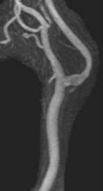An amendment was approved for the CREST-2 trial in February, 2018 to add a **carotid plaque imaging study to be done at a baseline visit**. The study will image components of the plaque and correlate them with follow-up clinical and imaging findings. The new MRI imaging sequences available at Clinical Sites have demonstrated that routine clinical, large field of view, carotid plaque imaging accurately identifies intraplaque hemorrhage, lipid rich necrotic cores and plaque ulceration. A large lipid rich necrotic core is at increased risk of developing new intraplaque hemorrhage or ulceration. Identifying the presence of intraplaque hemorrhage is particularly important having been associated with a high risk for TIA and stroke. A large lipid rich necrotic core has been shown to respond optimally to intensive statin therapy. Adding carotid plaque characterization to the CREST-2 trial allows correlation with clinical end-points such as TIA or stroke as well as the presence and change of silent brain lesions. All CREST-2 patients are eligible to undergo this one-time carotid plaque imaging at baseline.

## Protocols for carotid plaque imaging

No test scans for carotid plaque imaging need to be sent to the VIC for credentialing.

We have developed optimum scanning protocols for carotid plaque imaging on various GE and Siemens machines. These protocols are listed below. You can utilize the protocol appropriate to the machine available at your institution. The sequence parameters in the listed protocols should be followed as closely as possible allowing for differences in specific MRI models and software levels.

To save your and your patient’s time and effort, we have also developed a single set of MR imaging sequences that combines the carotid plaque imaging (carotid plaque imaging) with CREST-H imaging sequences required at baseline if your patient also agrees to enroll in CREST-H. You will need to schedule only one visit to the MR scanner and your patient will get all the scanning done during that single entry into the scanner. The combined protocols are listed on pages 42 and 45. Neuroradiology personnel are available to answer any questions that you or your radiology colleagues may have regarding optimizing and implementing the protocol at your site. If your Site has a different machine not listed in the manual, please reach out to us and we will facilitate the development of the protocol by our Neuroradiology experts for you. Since these protocols have been developed for clinical MRI machines, it is anticipated that all Sites will have the capability to provide these images. The VIC will review the images for quality, and will provide an over-read to be archived in the trial database.









## Reimbursement for carotid plaque imaging

The carotid plaque study is a part of the CREST-2 protocol and will be reimbursed by the study. An updated contract for reimbursement must be in effect. Please contact the Clinical Coordinating Center if you have questions about whether your Site has such a contract, or to initiate the contract.

## Form to be filled electronically for carotid plaque imaging



# END OF STUDY BRAIN MRI IN CREST-2

An amendment was approved for the CREST-2 trial in February, 2018 to add a **brain MRI study to be done at the end of the study**. This will involve obtaining a standard brain MRI that will allow us to assess silent infarction, white matter hyperintensity volume and microbleeds that may have accumulated over the 4-year CREST-2 study period. This scan will enhance our understanding of functional outcomes at the end of CREST-2. We hope and anticipate that all CREST-2 patients will continue to follow-up for the 4-year duration of the study; however, if, for any reason, they exit the study earlier, then this brain MRI would be performed at that time point. All CREST-2 patients are eligible to undergo this one-time carotid plaque imaging at baseline.

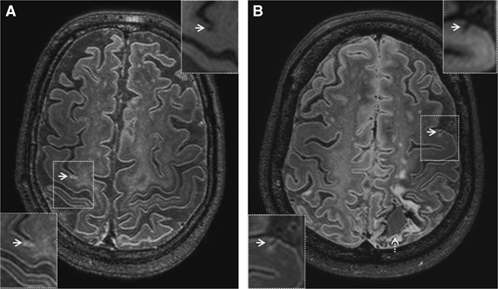

## Protocols for end of study brain MRI

No test scans for brain MRI need to be sent to the VIC for credentialing.

We have developed optimum scanning protocols for brain MRI on various GE and Siemens machines. The sequence parameters in the listed protocols should be followed as closely as possible allowing for differences in specific MRI models and software levels. VIC personnel are available to answer any questions that you or your Neuroradiology colleagues may have regarding optimizing and implementing the protocol at your site. If your Site has a different machine not listed in the manual, please reach out and we will facilitate the development of the protocol by our Neuroradiology experts for you. Since these protocols have been developed for clinical MRI machines, it is anticipated that all Sites will have the capability to provide these images. The VIC will review the images for quality, and will provide an over-read to be archived in the trial database.









## Reimbursement for end of study brain MRI

The end of study brain MRI is a part of the CREST-2 protocol. The Centers for Medicare and Medicaid have consented to reimburse for this scan provided the study is appropriately coded for billing purposes. The code to be used is as follows: MRI Brain without contrast CPT code #70551. No changes in your contract with CREST-2 Clinical Coordinating Center (CCC) are required.

## Form to be filled electronically for end of study brain imaging



# BRAIN IMAGING FOR CREST-H

CREST-H is designed to determine whether the subset of CREST-2 patients with cerebral hemodynamic impairment and mild cognitive impairment will benefit cognitively from revascularization. All subjects enrolled in CREST-H will get a special CREST-H MRI scan (H-MRI) at baseline to look for hemodynamic flow impairment. In addition to information on perfusion, the CREST-H MRI scan will also include structural sequences to look for silent brain injury. Once these images are submitted for review to the VIC, we will inform you whether the scan shows that the patient has hemodynamic impairment. Those who have hemodynamic impairment at baseline will then receive a follow up MRI at 1 year.

## Protocols for CREST-H and carotid plaque imaging

**Test imaging and Site credentialing required prior to CREST-H enrollment:**

Sites participating in CREST-H must first undergo credentialing of perfusion weighted imaging (PWI) sequences that are a vital part of the CREST-H imaging protocol. Prior to site initiation, we will require and review a sample dataset of source images from a PWI test scan to ensure adequate image quality. Each site must submit a PWI test scan. The scan can be from a patient who has undergone perfusion imaging for clinical reasons such as a stroke or brain tumor. Test scans must be de-identified per the study protocol and uploaded to U Maryland as described below. Training and assistance with implementation of the PWI protocol will be performed via telephone, training video conference, or on-site as needed. Approval from the CREST-H coordinating center will be required before a site is green-lighted to begin enrollment in CREST-H.

**Overview of the protocol**

To save your and your patient’s time and effort, we have developed a single combined MR imaging protocol for carotid plaque and CREST-H imaging since both need to be performed at baseline. This single protocol combines the carotid plaque imaging (carotid plaque imaging) and the CREST-H imaging (H-MRI) sequences. You will need to schedule only one visit to the MR scanner and your patient will get all the scanning done during that single entry into the scanner. We have developed optimum Gadolinium injection recommendations, and scanning protocols, on the most commonly used MRI scanners. The scan acquisition order set should be placed on one or more designated MRI scanners at your institution, preferably uniquely labeled as the “CREST-H” set. You should find your own scanner manufacturer and field strength from the tables below for specific recommended scan parameters. The sequence parameters in the listed protocols should be followed as closely as possible allowing for differences in specific MRI models and software levels. If for some reason a patient is able to do CREST-H imaging alone and not carotid plaque imaging, we have also provided the imaging protocol for CREST-H alone.

Neuroradiology personnel are available to answer any questions that you or your radiology colleagues may have regarding optimizing and implementing the protocol at your site. If your Site has a different machine not listed in the manual, please reach out to us and we will facilitate the development of the protocol by our Neuroradiology experts for you. Since these protocols have been developed for clinical MRI machines, it is anticipated that all Sites will have the capability to provide these images. The VIC will review the images for quality, and will provide an over-read to be archived in the trial database.

The CREST-H PWI (H-MRI) acquisition protocol is standardized across all CREST-H sites, using sequential T2*-weighted (gradient echo) EPI time-sequence scanning. Standardized contrast agent injection protocol and appropriate preparation or IV setup is required to reproducibly administer an adequate bolus of contrast material that will ensure good scan quality.

**Gadolinium protocol:**

1. Right antecubital vein IV placement of an 18 gauge catheter is required.

2. Prior to hooking up the power injector, flush the IV with 2.5 mL saline to ensure IV patency.

3. Load the power injector with a weight specific dose of contrast and 20cc saline flush.

4. Cover the indicated area with maximum number of slices for TR from the vertex inferiorly.

5. Using the power injector, inject the appropriate weight based amount of contrast at 5mL/sec and a 20mL saline flush at 5 mL/sec.

6. Inject contrast when there is 2:15 remaining in scan (45 SEC DELAY). Make sure the sequence is producing mages before you inject.

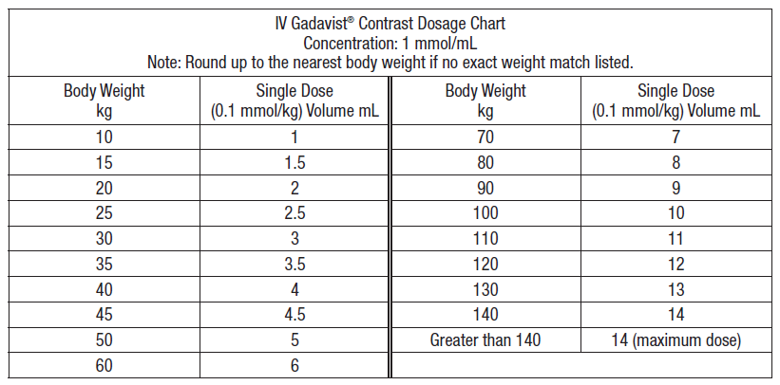

**Scanning protocols for patients participating in CREST-H and undergoing carotid plaque imaging:**









**Scanning protocols for patients participating in CREST-H but not undergoing carotid plaque imaging:**









***CT perfusion imaging acquisition***

CT perfusion (CTP) is a commonly performed imaging study especially in the setting of acute stroke. All CREST-H centers likely perform CTP on a routine basis with established protocols for brain perfusion studies which would be acceptable for the research scan. While a single protocol is not mandatory at participating sites, the following parameters can be used as a guide based upon a Siemen’s Flash scanner utilizing the common shuttle mode:

|  |  |  |
| --- | --- | --- |
|  | **Non-contrast head** | **CT Perfusion** |
| Coverage | Top C1 lamina to vertex | Top C1 lamina to vertex |
| Scan type | Spiral | Dynamic Multi 4D |
| Rotation Time (sec) | 1 | 0.28 |
| Collimation | 128 x 0.6 | 32 x 1.2 |
| 4D Range | NA | 100 mm 1.5 sec |
| Multi Cycle time | NA | 1.5/Multiple ON |
| Pitch | 0.6 | None |
| kVp | 120 | 80 |
| Effective mAs | 350 | 200 |
| CARE Dose 4D | Off | NA |
| Scan Field (mm) | 300 | 300 |
| Prep Delay | Min allowable | 2 sec |
| Min. Retro (mm) | 0.6 | 1.5 |
| CTDI-vol (mGy) | 53 | 8.6/scan, 1.5 sec scan time |
| Recon Kernel | J40 | H20 |

An 18 or 20 gauge peripheral IV is inserted, preferentially within the right arm. A contrast agent such as Omnipaque 350 is administered by a split does as follows: 50 mL Omnipaque 350 IV at 7 mL/second, followed by 50 mL 0.9% NaCL at 7 mL/second (we have found that if the contrast cannot be given at 7ml/second a suboptimal CTP exam may occur). The images will be processed with a semi-automated system such as the OleaSphere software platform that computes quantitative perfusion maps using deconvolution of the tissue and arterial signal in an expedited manner, yielding standardized data regardless of the acquisition system at each site. As with CREST-H MRI perfusion studies, hemodynamic impairment will be defined as Time-To-Peak greater than 2 seconds in the middle cerebral artery and anterior cerebral artery territories of the ipsilateral hemisphere to the carotid lesion compared with the same territory in the opposite hemisphere. Training and assistance for CTP imaging will be provided as needed.

## Reimbursement for CREST-H MR imaging

The CREST-H imaging protocol will be reimbursed by the study. A CREST-H contract for reimbursement must be in effect. Please contact the Clinical Coordinating Center if you have questions about whether your Site has such a contract, or to initiate the contract.

# NAMING OF IMAGE FILES BEFORE TRANSFER TO THE VIC

Naming electronic files in a systematic way before uploading them to the VIC at University of Maryland allows for better tracking and routing of images.

Electronic file names will include four pieces of information:

1. **PID1 of the patient**: A four character alpha numeric unique designator assigned to a patient during randomization
2. **The occasion for the study**: Occasion for imaging is the reason why the study was performed. The options for this field are:

BAS- baseline

1YR- one year follow up

2YR- two year follow up

3YR- three year follow up

4YR- four year follow up

OTH- any other occasion that does not fall into the categories above; e.g. 44 day, unscheduled

1. **The type of imaging the file includes:** Type of imaging indicates what kind of study the file contains. The options for this field are:

DUS- duplex ultrasound

MRA- magnetic resonance angiogram

CTA- CT angiogram

ANG- catheter-based angiogram

PWI- CREST-H imaging protocol files

PLQ- Plaque imaging protocol files

MRI- Including end-of-study imaging protocol files

OTH- imaging that does not fit in the categories above

1. **The date the study was performed**, in MMDDYYYY format. No dashes, slashes, or spaces.

**Example:**

The filename for a baseline ultrasound performed on August 8, 2017 on a patient with PID1 of 74DD would be:

74DD_BAS_DUS_08242017

**For CREST-H scans**, once the images are acquired, place all the de-identified image files in a Zip file and label the Zip file with the following nomenclature Note that all CREST-H imaging files **will have “_H” at the end**:

PID1_BAS/1YR_PWI_MMDDYYYY_H

**For CREST-H test scans**, use the site ID instead of a patient ID and replace the timing with TEST:

P(siteID)_TEST_PWI_MMDDYYYY_H

**File Naming Summary**

**PID1:**

4 character alpha

numeric identifier

assigned to a

patient when

he/she is

randomized

**Occasion Options:**

**BAS**- baseline

**1YR**- one year follow-up

**2YR**- two year follow-up

**3YR**- three year follow-up

**4YR**- four year follow-up

**OTH**- any other occasion that does not fall into the categories above;

e.g. 44 day, unscheduled

**Type of Imaging Options:**

**DUS**- duplex ultrasound

**MRA**- MR angiogram

**CTA**- CT angiogram

**ANG**- catheter angiogram

**PWI**- CREST-H imaging exam

**PLQ**- plaque imaging exam

**MRI**- MRI exams including

end-of-study exams

**OTH**- imaging that does not

fit in the categories above

**Date of Study:**

2 digit month

2 digit day

4 digit year

e.g. September 14, 2017

becomes 09122017

# SUBMISSION OF IMAGES TO THE VIC

**De-identification of images**

All images sent to the VIC must be de-identified. The de-identification process may be different at each Site. Find out how your institution de-identifies and uploads images. Some systems may allow the patient to be labeled from the start with the CREST-2 PID1. If the VIC receives images with identifiable information (other than the patient CREST-2 ID) the images will be deleted and the site will be required to re-send de-identified images.

Only electronic versions of images are accepted at the VIC

The following formats are NOT acceptable:

* Conventional gray scale paper or glossy paper prints or photocopies or film prints
* FAX copies
* Videotapes

**Methods to transmit images to the VIC**

Upload all imaging scans in DICOM format for centralized processing at U Maryland via your ftp links already established as part of CREST-2.

1. Navigate to your site folder in Sharepoint

2. Select “New File Entry”

3. Enter the name of the Zip file containing your images in the Title field

4. Choose the Zip file for the upload

5. Select OK on the lower right

6. You can enter text in the Description field if you wish

* Direct ftp transfer of DICOM or JPEG files **(preferred)**
* CDs/DVDs with DICOM or JPEG files (second best option)

If mailing a CD/DVD, please do so within 48 hours of the examination to the VIC via USPS, FedEx or UPS with Tracking number to:

**Please write “Box 328” on envelope and highlight with highlighter**

Attn: John Yokemick

The Vascular Imaging Core Facility

University of Maryland School of Medicine

22 South Greene Street, Room S3B02C

Baltimore, MD 21201

**The following information will be accumulated in regular reports:**

1. Imaging CRFs that have been locked by clinical centers and received by UAB

2. MRI raw data files that have been received from clinical centers by U Maryland

3. MRI files transmitted to Mayo Rochester

4. MRI files transmitted to UCLA

5. MRI post-processed images received from Mayo Rochester

6. MRI perfusion post-processed scans received from UCLA

A notification regarding outstanding/overdue CRFs, scans, post-processed images from their respective sources will be sent to sites from UAB.

# OPTIONS AND REIMBURSEMENT FOR IMAGING STUDIES IN CREST-2 AND CREST-H

**How to decide on required imaging studies:**

|  |  |  |  |  |  |
| --- | --- | --- | --- | --- | --- |
|  | Baseline | Year 1 | Year 2 | Year 3 | Year 4 |
| Patient already enrolled in CREST-2 | X | X | X | X | End of study Brain MRI |
| New patient in CREST-2 also enrolled in CREST-H | Combined CREST-H and carotid plaque MRI | Some patients will require CREST-H MRI | X | X | End of study Brain MRI |
| New patient in CREST-2 not enrolled in CREST-H | Carotid plaque MRI | X | X | X | End of study Brain MRI |

**Reimbursements for various imaging studies:**

|  |  |  |  |  |
| --- | --- | --- | --- | --- |
| **Purpose** | **Target** | **Name of study** | **Timing** | **Reimbursement** |
| CREST-2 |  |  |  |  |
| To determine eligibility for enrollment and annual follow-up | Carotid artery | CDUS | Baseline and every year | Included in $2000 paid for all enrollment visit activities |
| To determine individual components of the carotid plaque | Carotid plaque | MRA | Baseline | Up to $ 800 |
| To look for presence of silent brain lesions | Brain parenchyma | MRI | At exit from study | Medicare patients are reimbursed |
| If additional imaging was used to determine eligibility or to determine appropriate trial (CEA or CAS); submit one or more | Carotid artery | * CTA * MRA * CBA | Baseline | Clinical care |
| Pre-review of imaging studies that Clinical Sites may send for an opinion prior to enrollment; submit one or more | Carotid artery | * CDUS * CTA * MRA * CBA | Baseline | Clinical care |
| Quality control of CAS procedures | Carotid artery | Procedural CBA | Procedural | Clinical care |
| To evaluate a potential neurological event; submit one or more | Brain parenchyma | * MRI/MRA * CT/CTA | Any time | Clinical care |
| CREST-H |  |  |  |  |
| To measure brain perfusion and look for silent brain injury | Brain | CREST-H scan includes PWI and brain imaging | Baseline and at 1 year follow-up | $1200 at baseline (imaging, forms)  $950 on follow-up (imaging & forms) |

For the purposes of determining time needed within the MR imaging unit and for negotiating rates with your radiology services, the following CPT codes reflect the CREST-2 and CREST-H imaging protocols reasonably closely (Note that these are “research” scans, and not standard of care. Specific research rates are generally available at most institutions):

1. CREST-2 carotid plaque scan: MRI cervical spine with and without contrast CPT #72156

2. CREST-2 carotid plaque scan and the full CREST-H scan (PWI + structural brain): MRI cervical spine with and without contrast CPT #72156 & MRI brain with and without contrast CPT #70553

3. The full CREST-H scan (PWI + structural brain): MRI brain with and without contrast CPT #70553

4. CREST-2 end of study MRI: MRI Brain without contrast CPT code #70551