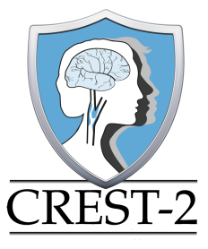
CREST-2 Manuscript Proposal Form

- Suggested Title:
- Writing Group (list individual with lead responsibility first):

(Lead)

NOTE: At least two site principal investigators will typically be included in all manuscript proposals. The Publications Committee Chair will assist in determining appropriate site PIs to be added to the form following submission.
- Rationale:

- Main Hypothesis:

- Data required (variable, source, inclusions/exclusions)
Note: contact Jenifer Voeks (voeks@musc.edu) or Yu Zhang (zhangyu@uab.edu) at the SDCC to confirm availability of data variables:

Please submit manuscript proposal form to Robert D. Brown, Jr., MD (brown@mayo.edu), Chair, CREST2 Publications and Presentations Committee.

